**“Experiment 3.3”**

Student Name: **SUMIT KUMAR** UID: **20BCS8226**

Branch: **CSE** Section/Group: **808 A**

Semester: **5** Date of Submission: **12-11-22**

Subject Name: **Multimedia Technologies Lab**  Subject Code: **20CSP-339**

**1. Aim/Overview of the practical:**

Create a suitable background with clouds and mountains on one layer. Draw the Sun on another layer. On the third layer draw birds. Provide animation to show the birds flying across the Sun that keeps fading using Macromedia flash.

**2. Which logistics used:**

Hardware Requirements: - Minimum 384MB RAM, 100 GB hard Disk, processor with 2.1 MHz

Software Requirements: - Macromedia flash

**3. Steps for experiment/practical/Code:**

Step 1: Go to Macromedia Flash 8, click on the flash document click OK.

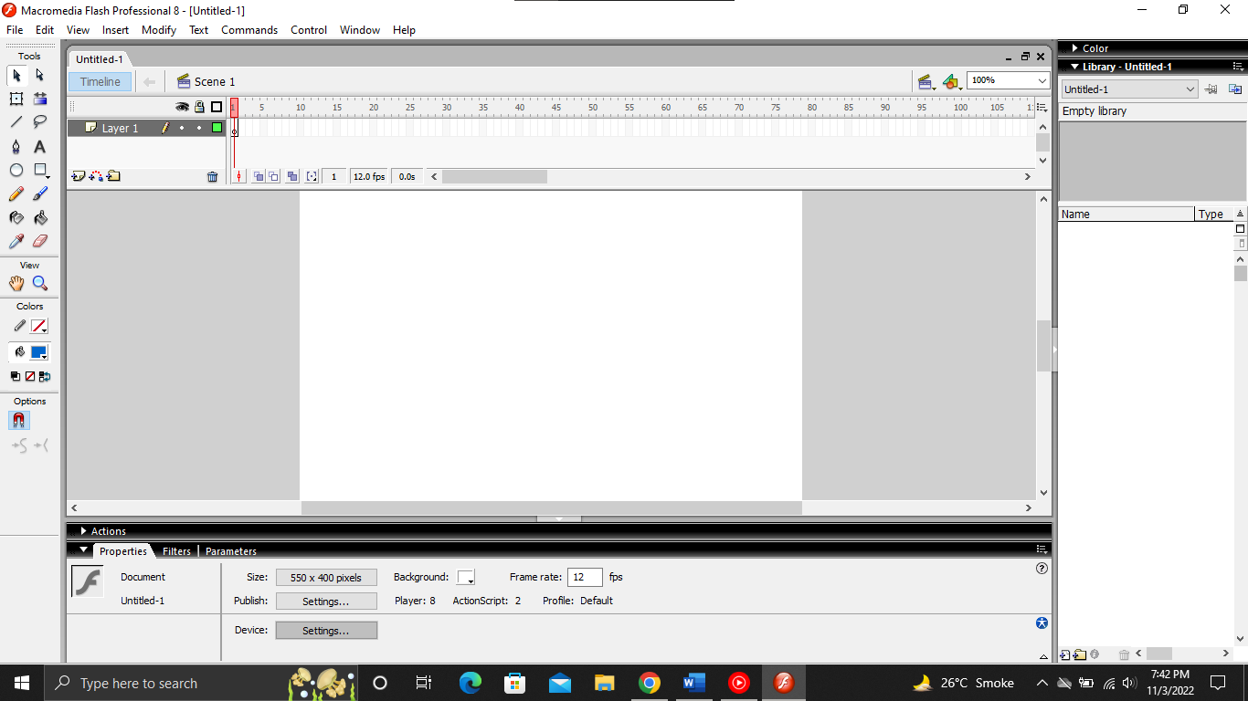

Step 2: Double-click on one layer and rename it as the sun

Step 3: Using the oval tool, draw the sun.

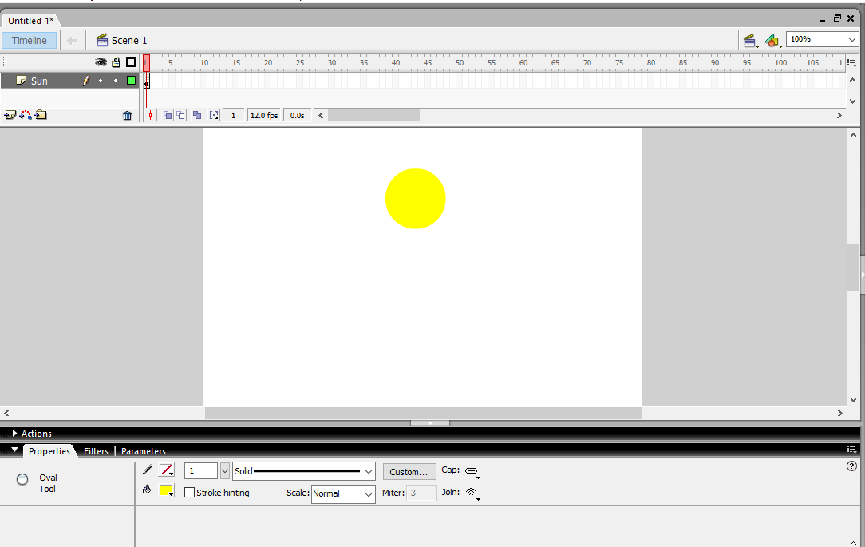

Step 4: Select the sun and convert it into a symbol (F8) and then go to the 50th frame and insert a keyframe (F6)

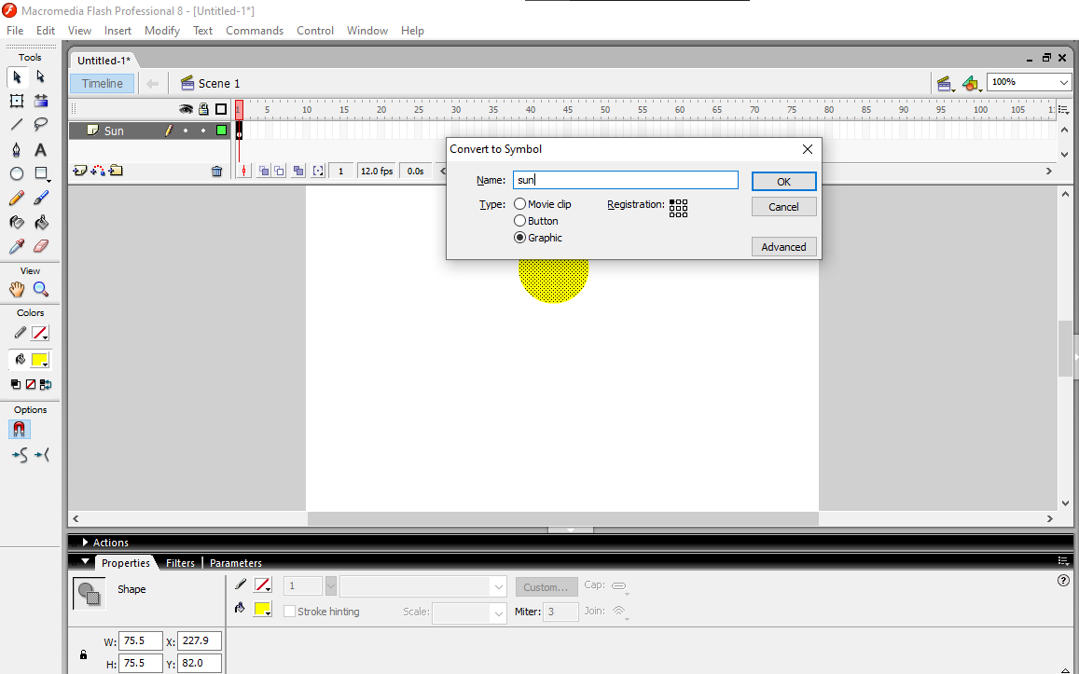

Step 5: By using free transform tool resize the sun and set the position.

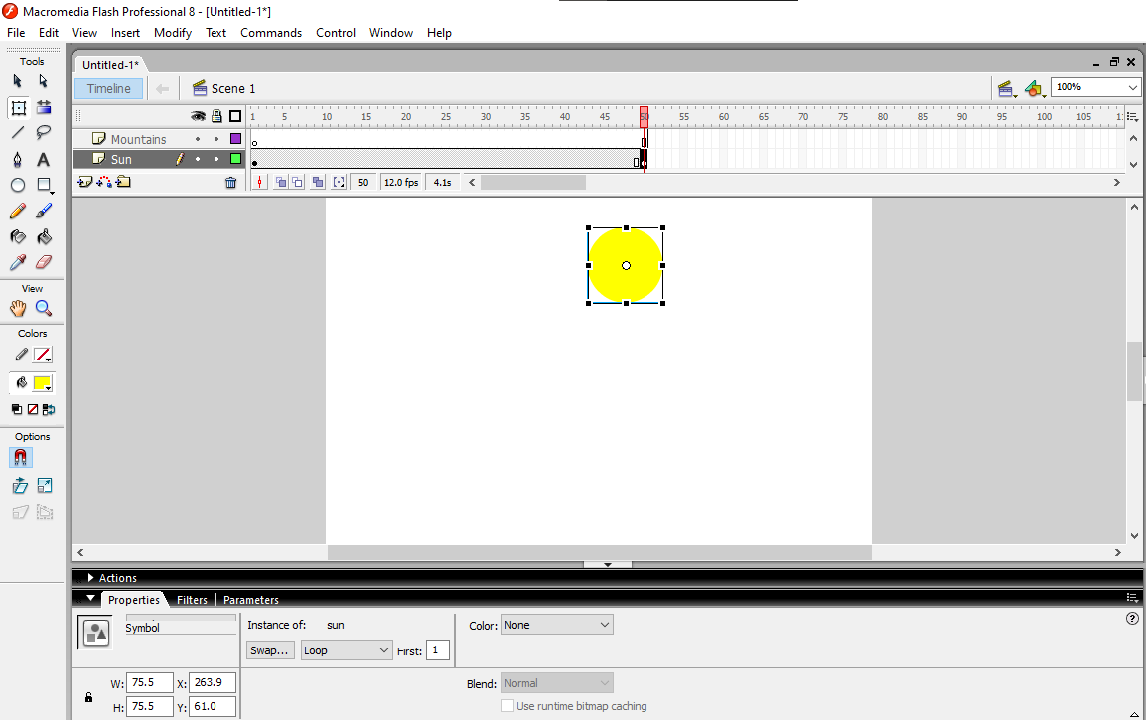

Step 6: Insert a new layer and rename it as a mountain.

Step 7: Using a pencil or line tool, draw a mountain.

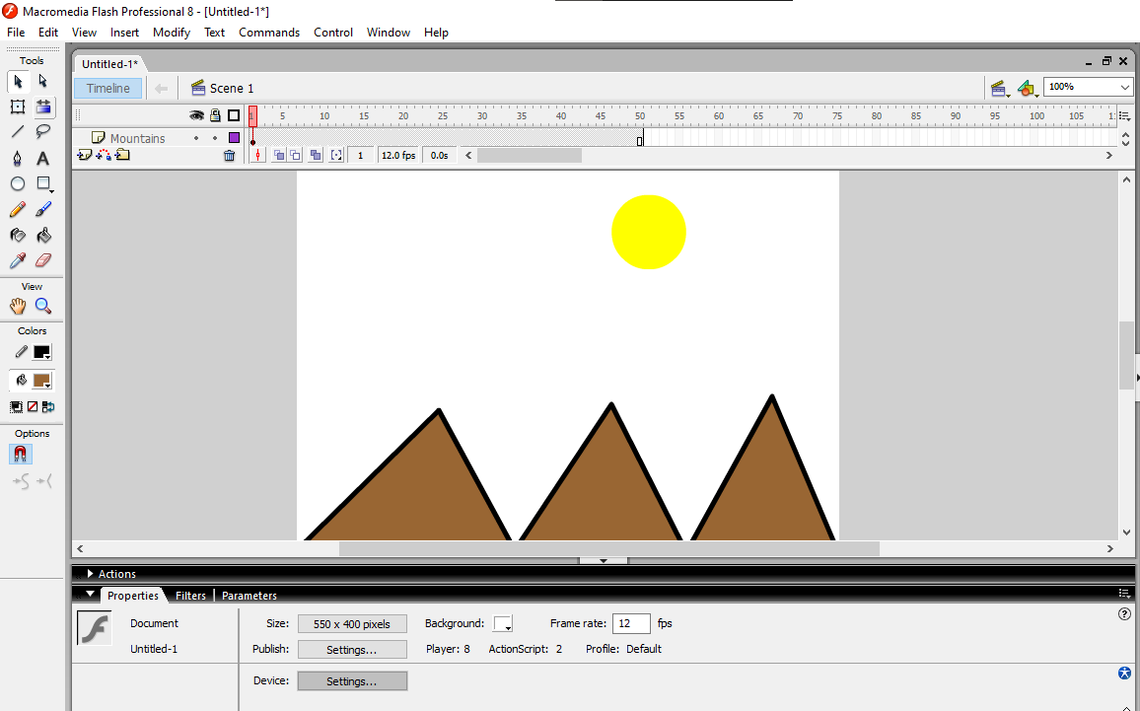

Step 8: Go to the 50th frame and insert a keyframe on the mountain layer.

Step 9: Insert a new layer and rename it as a cloud.

Step 10: Using a pencil or brush tool, draw a cloud.

Step 11: Go to the 50th frame and insert a keyframe on the cloud layer.

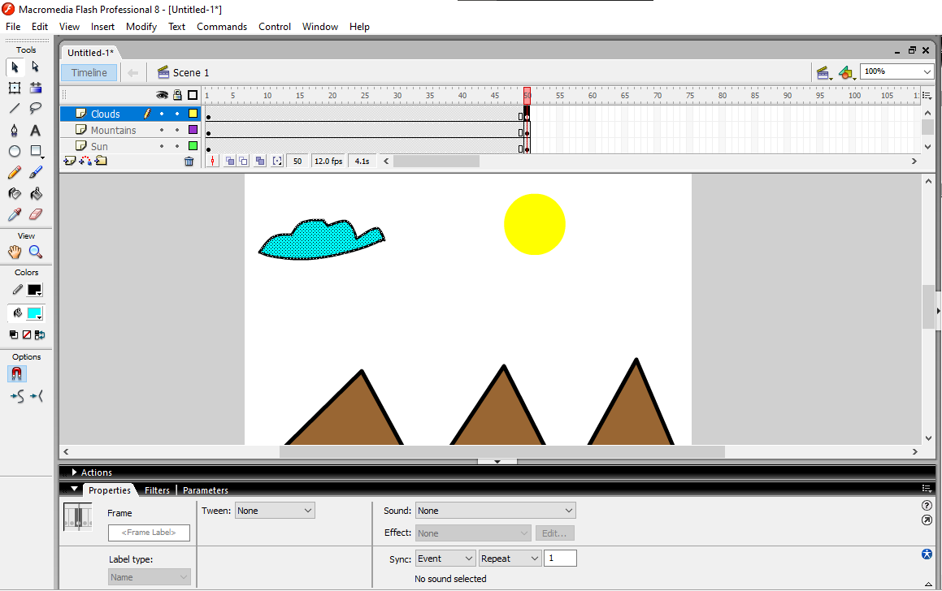

Step 12: Insert a new layer and rename it like birds.

Step 13: Draw the birds using pencil or brush tool, select all the birds by holding the shift key and insert a keyframe for birds’ layer at intervals of 5.

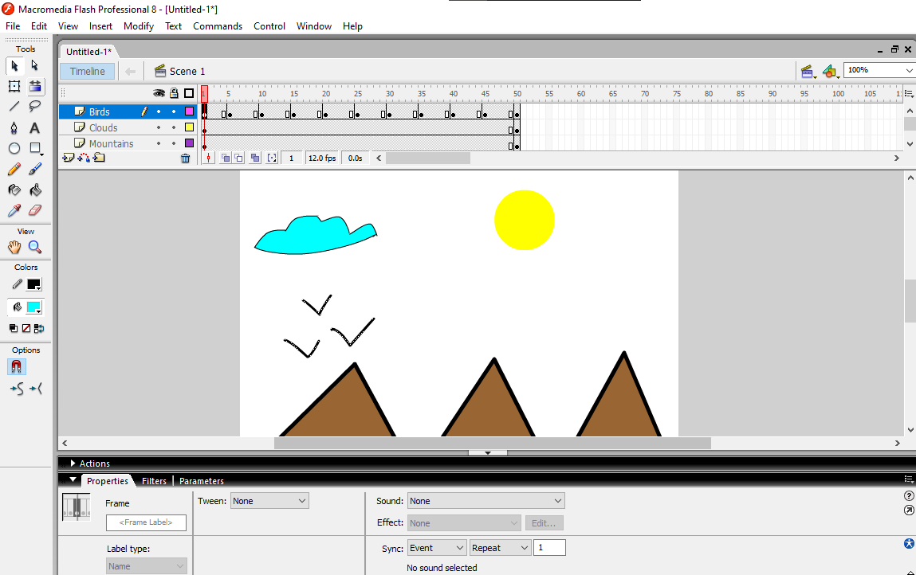

Step 14: Press Ctrl + Enter to test the movie.

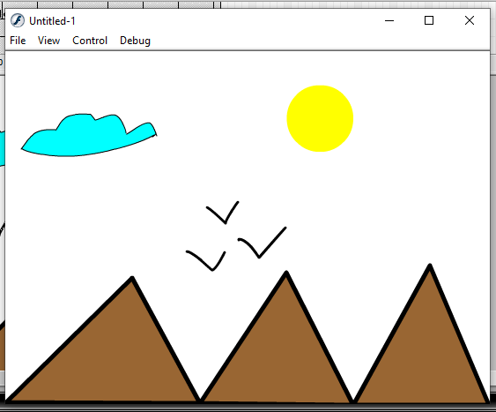

**Learning outcomes (What I have learnt):**

**1.** Learnt how to install macromedia flash.

**2.** Learnt the different features of macromedia flash.

**3.** Learnt about uses of different tools.

**4.** Learnt how to make animations using macromedia flash.

**Evaluation Grid (To be created as per the SOP and Assessment guidelines by the faculty):**

|  |  |  |  |
| --- | --- | --- | --- |
| Sr. No. | Parameters | Marks Obtained | Maximum Marks |
| 1. |  |  |  |
| 2. |  |  |  |
| 3. |  |  |  |
|  |  |  |  |